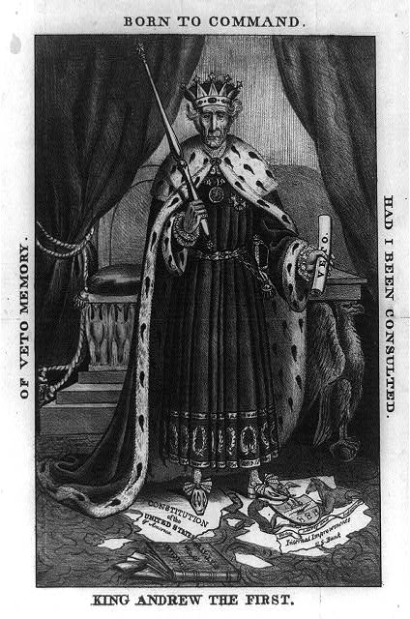
Questions:
- Who is the figure depicted in the cartoon?
- How has the artist portrayed him?
- Why do you believe the artists chose to depict him in this way?
- What is a presidential veto?
- What controversial action did President Jackson take in 1832 – 1833 that is the subject of this cartoon?
- What items in the cartoon refer to the action in #5?

General Jackson Slaying the Many Headed Monster
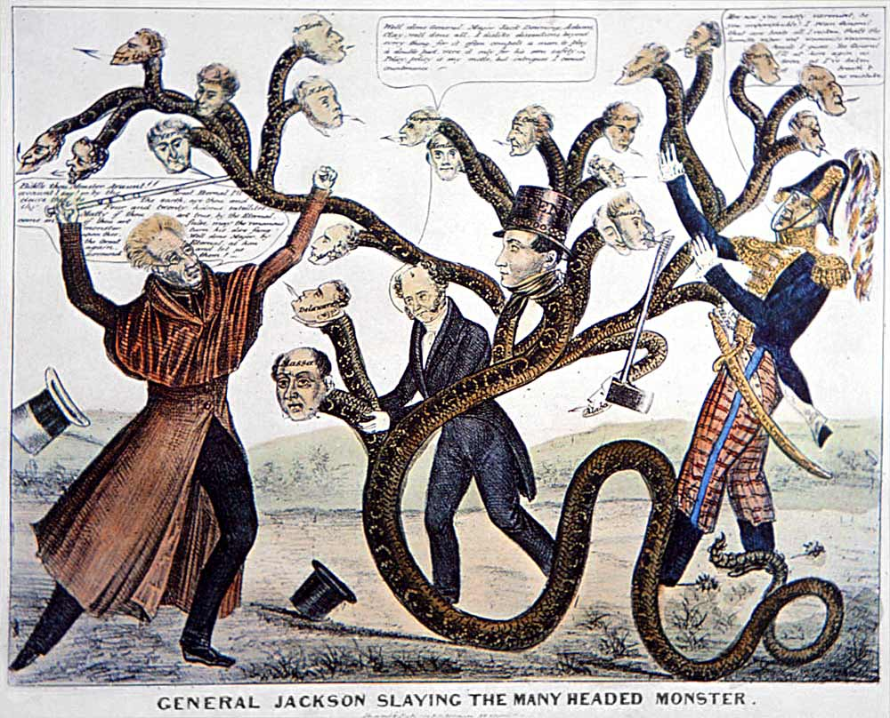
King Andrew the First

